**Automatic generation/update of a Microsoft Outlook invite for an event in Dynamics 365 Marketing**

**Purpose/Scenario:**

This solution automates sending of an outlook invite for an event when participants are already added to an event registration.

After an outlook invite is sent, if critical session fields in Dynamics 365 Marketing are updated (such as start time, end time), an updated meeting invite gets automatically triggered.

**Assumption:**

Participants are already added to Event Registration

**Solutions:**

**Unmanaged Solution:** InvitesonEventLive_1_0_0_0.zip

**Managed Solution:** InvitesonEventLive_1_0_0_0_managed.zip

**Prerequisite:**

Marketing solution should be installed in the organization on which the above solution is being imported on

**Steps:**

1. Import the solution “MSFT Invites On Event Live”
2. This solution contains the following components

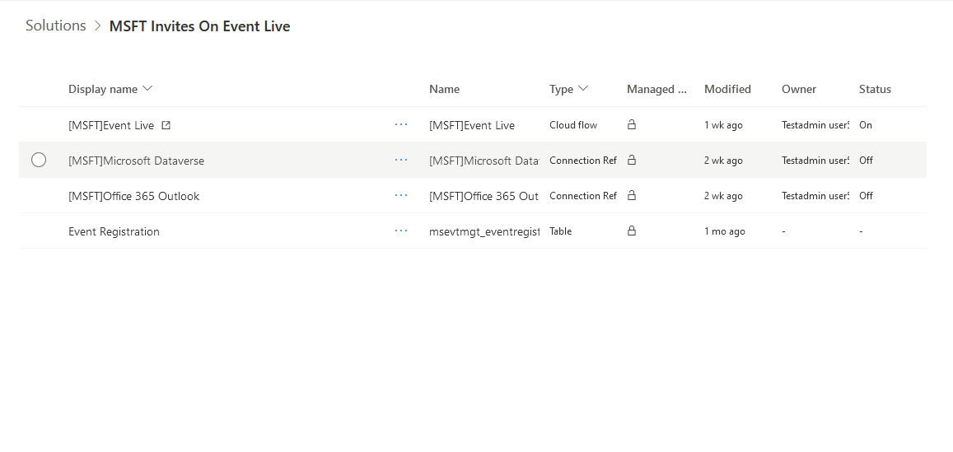

1. This solution will install two connection references i.e., Microsoft Dataverse and Office 365 Outlook. Post installation of the solution you must configure the above two connection references with the respective users by clicking on the ellipsis and select Edit

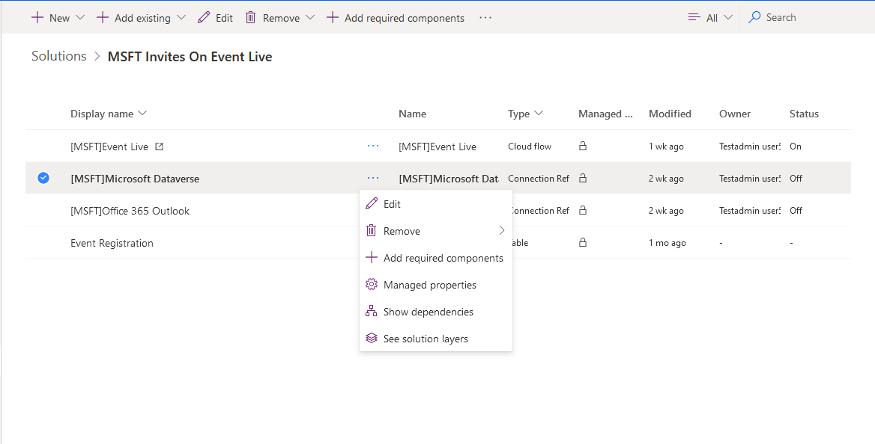

1. Cloud flow
2. Create Invitation when Event Registration is Live- This flow triggers when a record status updated to live in the Event Registration record and sends out the outlook calendar invites to the registered contact for a particular Event. This also updates a field “Outlook Calendar Id” present in the Event Registration table. Using this column, we can identify whether the invites has been sent or not

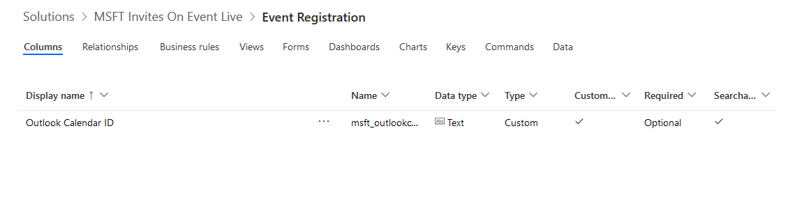

These steps have to be followed for activating the flows

1. Configure the connection references as mentioned in step 3 and choose the valid references here

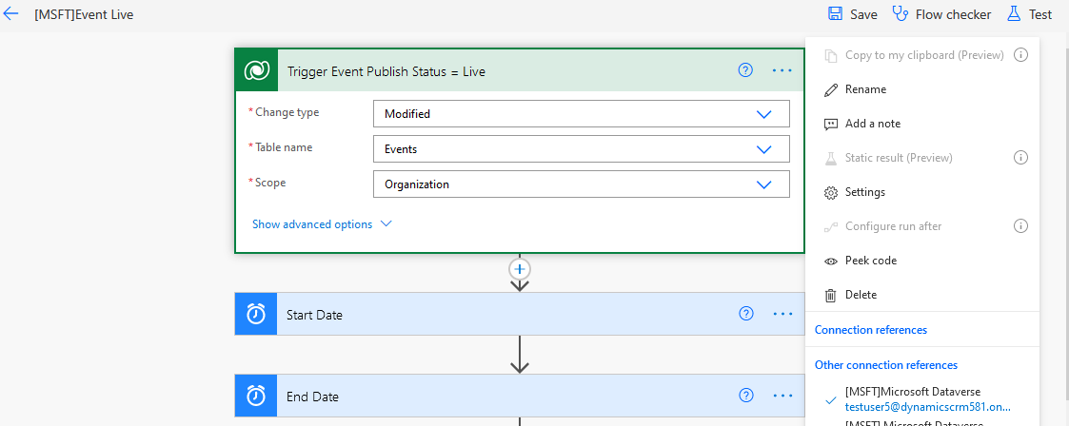

For outlook

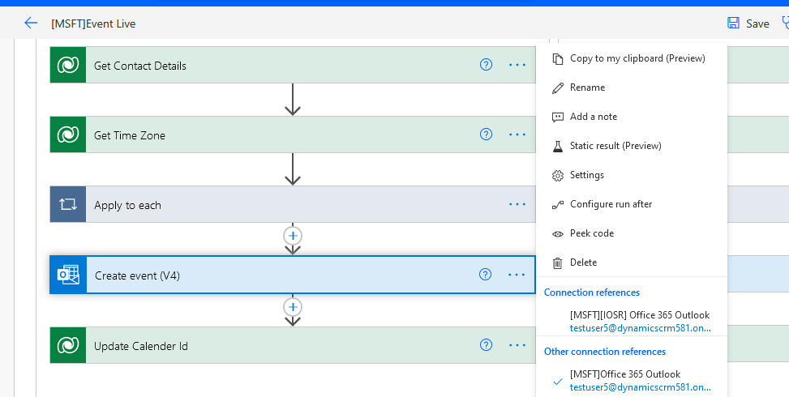

1. Please select the Calendar Id. This must be done manually because once the connection changes this Id gets changed automatically.

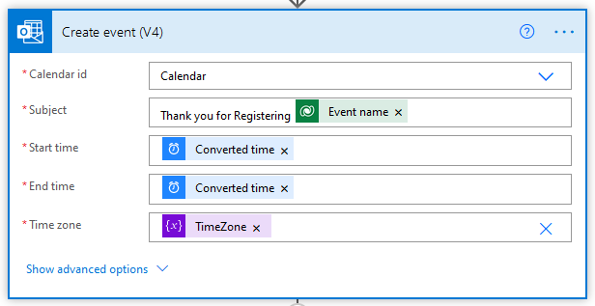

1. This Create Event has a generic Email body. If you wish to change you can change it by modifying the body below

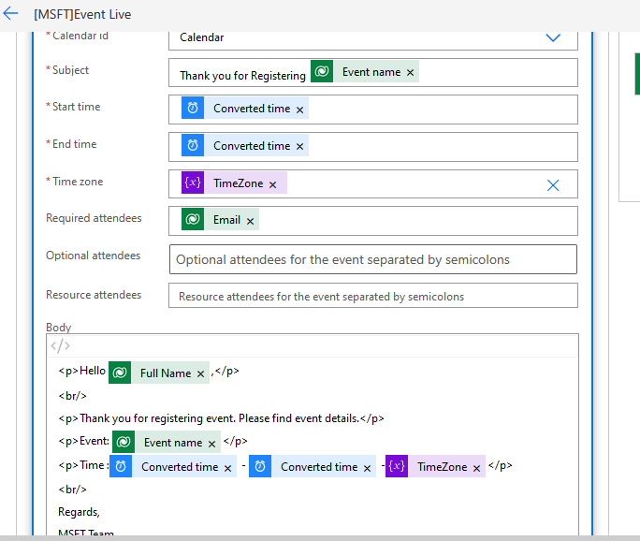

1. In this step we are updating outlook calendar id on Event registration to track whether the invites have been sent or not

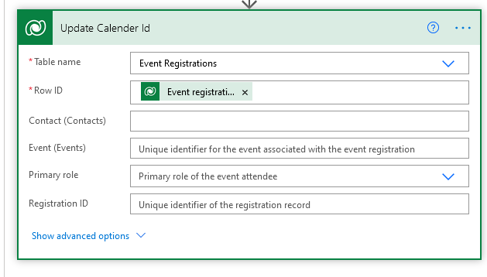

Post these steps you can click on Save and Turn on the flow by clicking on “Turn on”

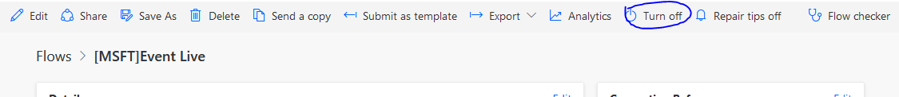

1. Once the flow gets triggered the contact will be receiving a outlook calendar with the sample email body as below.

